Binary Tree Traversal
Traversal is a process to visit all the nodes of tree and may print their values too. Because, all nodes are connected via edges. We always start from the root node. That is, we can not random access a node in tree. There are three ways which we use to traverse a tree –
- In-Order Traversal
- Pre-Order Traversal
- Post-Order Traversal
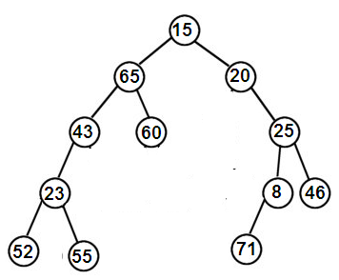

In-Order Traversal: (Left, root, right)
In this traversal method, the left sub tree is visited first, then root and the right sub tree. We should always remember that every node may represent a sub tree itself.
In-Order Traversal: 52,23,55,43,65,60,15,20,71,8,25,46

Pre-Order Traversal (root, left,right)
In this traversal method, the root node is visited first, and then left sub tree and finally right sub tree.
Pre-Order Traversal: 15,65,43,23,52,55,60,20,25,8,71,46

Post-Order: (left , right , root)
In this traversal method, the root node is visited last, First we traverse left sub tree, then right sub tree and finally root.
Post-Order Traversal: 52,55,23,43,60,65,71,8,46,25,20,15

Example: Tree Traversal
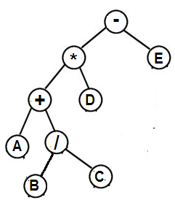
In Order Traversal : A + B / C * D - E
Pre-Order Traversal : - * + A / B C D E
Post Order Traversal : A B C / + D * E –

Example : -
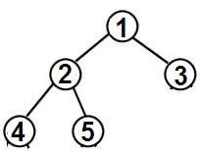

In Order Traversal : 4,2,5,1,3
Pre-Order Traversal : 1,2,4,5,3
Post Order Traversal : 4,5,2,3,1

Example :-
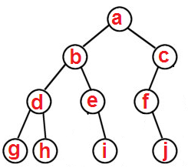
In Order Traversal : g d h b e i a f j c
Pre-Order Traversal : a b d g h e i c f j
Post Order Traversal : g h d i e b j f c a

Tree Traversals

Tree Traversal Introduction

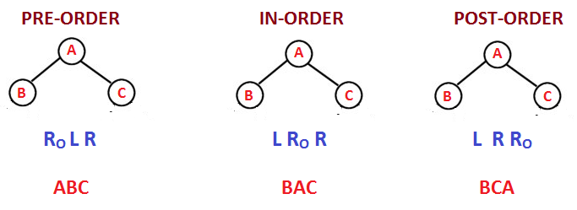

Short Trick

Tree Traversal 2 Guidelines and Tricks

Tree Traversal Guidelines.

Traverse the nodes from Top to Bottom

Traverse the Nodes from Left to Right

Pre – Order : 1st Time Traverse

In- Order : 2nd Time Traverse

Post-Order : 3rd time Traverse

1st Time Traverse means : When a node discovered for the first time (Top to bottom).

2nd Time Traversal means : When oing upwards from Left Child to Parents.

3rd Time Traversal means : When going upwards from Right child to Parent.

Note:

Apply Depth Traversal with the universal Tree Traversal Technique(e.g : Root Left Right)

Connect Empty Nodes as a leaf.

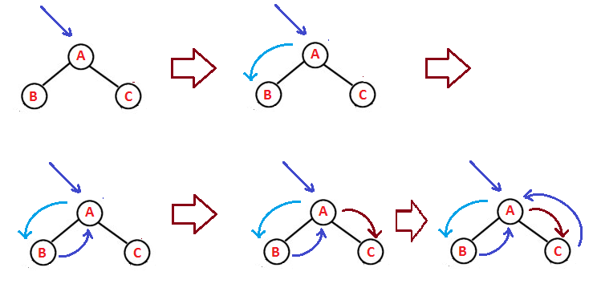

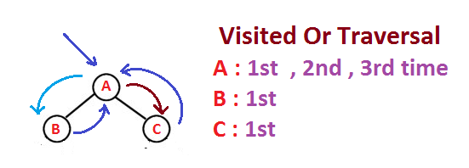

Tree Traversal Basic Example:

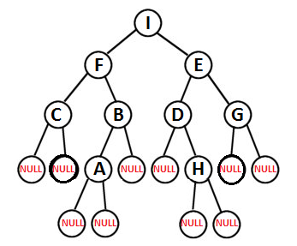
Find the PreOrder Traversal of the Following Tree.
Sol : IFCBAEDHJ
Find the InOrder Traversal of the Following Tree.
Sol : CFABIDHJEG
Find the PostOrder Traversal of the Following Tree.
Sol : CABFJHDGI

Practice Question:

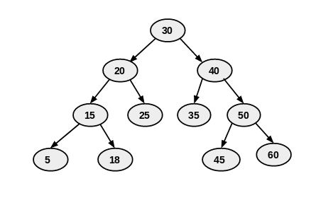
In order: {5 , 15 , 18 , 20 , 25 , 30 , 35 , 40 , 45 , 50 , 60}
Preorder: {30 , 20 , 15 , 5 , 18 , 25 , 40 , 35 , 50 , 45 , 60}
Post Order: {5, 18, 15 , 25 , 20 , 35 , 45 , 60 , 50 , 40 , 30}

Practice Question:
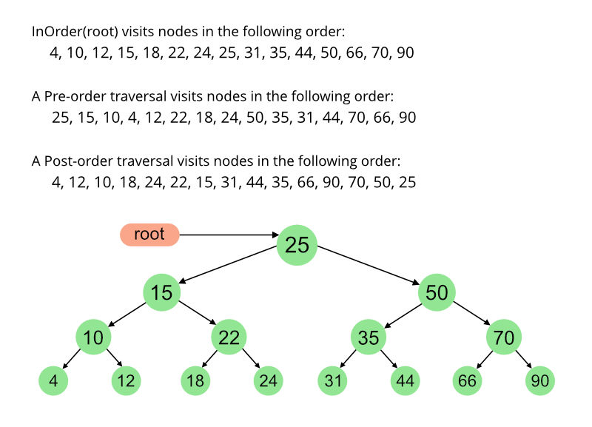

Tree Traversal Tree Construction In Order Preorder.

Construct the Tree from the Given Traversals

Pre-Order : IFCBAEDHJG

In-Order : CFABIDHJEG

SOL :

R₀LR Pre Order

L R₀R Post Order

Pre Order : IFCBAEDHJG R₀LR

In Order : CFABIDHJEG L R₀R

Recursive Solve:

We find root from Pre-Order

We find Left nodes and Right Nodes From Inorder

Example:
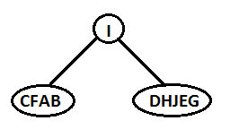
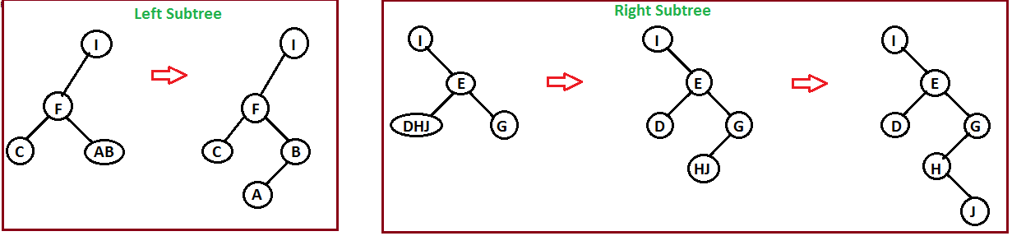
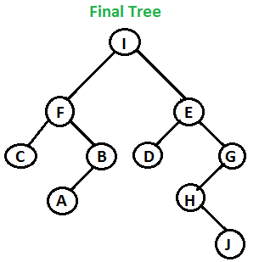

Worst Case Complexity When Linear Search Apply
Complexity to be searched vertex = V in
Pre- Order O(V)
Complexity to find searched vertex = V² in
In Order O(V²)
Where V is the no. of Vertices

Tree Construction from the given Traversals
Post Order: H B A I D C G E F A J
In Order: H J B G A C D I E K F
Sol :
Post Order: L R R₀
In-Order: L R₀ R
Conclusion:
To Construct Unique Binary Tree from given
INORDER – PREORDER
INORDER – POSTORDER
Requires O(V²)
Where V is the Vertices
In Worst Case (Linear Searching)
Tree Construction Pre-Order Post Order
Construct the tree from
Preorder : ABA R₀ L R
Post Order: CBA L R R₀
Sol: In this, Root Node can be find using PreOrder or Post Order

Approach Use: Brute Force (Hit and Try)
Time Complexity in Brute Force is O(2^{n})
Note: We can make Binary tree using Preorder and Post Order . But with this two we cannot create Unique Binary Tree or we will doesn’t find UBT.
Conclusion:
Let suppose, in an exam
- Preorder is given: ABC
- Post Order is given : CBA
And in Option IN-ORDER is given
Check for the Tree which satisfies the above order
Don’t Blindly say No: that which Preorder and Post Order is given
Final Conclusion
To Construct UNIQUE Binary Tree, In Order is compulsory
PRE – IN make UBT O(n²)
POST - IN make UBT O(n²)
PRE - POST cannot make UBT O(2^{n})

Binary Search Tree Introduction
Atmost 2 Children (Left < root <= right )
Binary Search Tree In Order Traversal
Find the In Order Traversal of BST

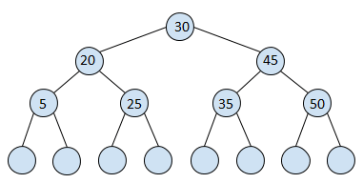

5 20 25 30 35 45 50

IMP Note: InOrder of Binary Search Tree is Always in Ascending Order
IMP Points : If Ques Arise
Pre-Order: 50 10 40 of BST
Find the Post Order
Sol:
As Know it is BST then arrange it in ascending Order
10 40 50
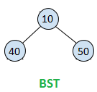
Know Make Post Order Using Above BST

BST Traversal GATE Problem
Question : GATE Problem : You are given a Binary Search Tree.
Whose Preorder is
50, 10 ,40,30,20,35,80,60,70,65,75
Find the Post Order ?
Solution :
In Order : 10,20,30,35,40,50,60,65,70,75,80
Advantage : In Tie Complexity , in the Binary Search Tree is Very Less because in In-Order Traversal is Sorted
O(nlogn)
IMP Note : Searching root node in In-Order traversal, the Algortithm Binary Search is used instead of Linear search because In –Order Traversal is Sorted.

Conclusion :
To construct Unique Binary Tree from given Pre-Order/ In Order or Post Order/ I-Order requires O(n²), If In-Order is not sorted, So in this Linear Searching requires O(nlogn) because in this Binary Search is use.

GATE Problems Assignments:
Ques 1 :
The Preorder traversal sequence of binary search tree is 30, 20, 10, 15 ,25 ,23, 39,35,42, which one of the following is the postorder traversal sequence of the same tree ?
- 10,20,15,23,25,35,42,39,30,
- 15,10,25,23,20,42,35,39,30
- 15,20,10,23,25,42,35,39,30
- 15,10,23,25,20,35,42,39,30
Solution : As given it is a BST then it will besorted.
In Order Traversal like :
10, 15 , 20 , 23 ,25 , 30 , 35, 39 , 42

PreOrder : 30,20,10,15,25,23,39,35,42
In Order : 10,15,20,23,25,30,35,39,42
We can Find Post Order through above two traversal .
Ques 2 :
Th inorder and Preorder traversal of a binary tree are d b e a f c g and a b d e c f g respectively.
The Post Order Traversal of the binary tree is
- d d b f g c a
- e d b g f c a
- e d b f g c a
- d e f g b c a

You are given the Post Order traversal P of a binary search tree on the n elements 1,2,3 ---- n . You have to determine the unique binary search tree that has P as its post order traversal. What is the time complexity of the most efficient algorithm for doin this ?
- Θ(logn)
- Θ(n)
- Θ(nlogn)
- None of the above, as tree cannot be uniquely determined.
Suppose the numbers 7,5,1,8,3,6,0,9,4,2 are inserted in that order into an initially empty binary search tree. The Binary search tree uses the usual ordering on natural numbers. What is the in-order traversal sequence of the resultant tree ?
- 7 5 1 0 3 2 4 6 8 9
- 0 2 4 3 1 6 5 9 8 7
- 0 1 2 3 4 5 6 7 8 9
- 9 8 6 4 2 3 0 1 5 7

Creating of Binary Tree from Basic Tree Traversal
We have already seen inorder, preorder and post order traversals. Now a question may come in your mind that is it possible to predict tree from any one traversal ? Answer is No !
Because the fact is that one traversal gives the ambiguous result.

Notes:
To predict the exact tree from the tree traversals we require atleast any two traversal.
Remember that- the last node in preorder sequence is always the root node and the first node in preorder sequence is always a root node.

Example:
Let us see the procedure of predicting a binary tree from given traversals.
Post-Order : H I D E B F G C A
In-Order : H D I B E A F C G
Step 1: The last node in post order sequence is the root node. Now observe inorder sequence locate the root node.

Example:
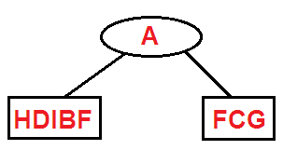
Step 2 :Now , with these alphabets HDIBE observe the postorder and sequences in inorder.
Post Order HIDEB
In-Order HDIBE
Here B is parent node, therefore pictorial tree will be.
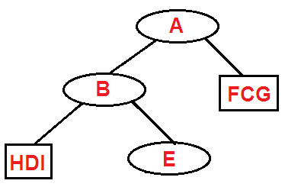
Similarly this Process occur till the all node is not set.

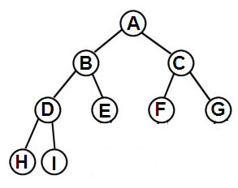
Binary Tree For Given Traversal

Example 2:
Preorder A B C D E F G H I
In-Order B C A E D G H F I
Solution :
Now, In this Example Pre-Order Sequence is given in Comparison with inorder.
As we Know that in preorder the first node is always root node/Parent node.
Solution:
Step 1:
The first node in the preorder sequence is always a root node. Then we must locate this root node in-order sequence. All the nodes left to this root node form the left sub-branch and all the nodes right to this root form the right sub branch.
So
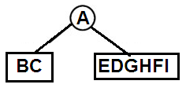

Similarly for BC
Inorder BC
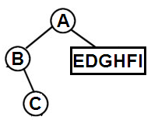
Similarly for EDGHFI Sequence
PreOrder is DEFGHI
Inorder is EDGHFI
D is parent node , E is Left Child and GHFI is right Child Branches.

